Dear PAC officers, chairpersons, and directors,
It is with a heavy heart that I share the sad news that one of our fellow officers and colleagues, John Sidor, passed away suddenly Wednesday, December 6th.
Many of us saw him Saturday at the PAC meeting and we shared an opłatek. Mariola and he were so excited to leave for Poland next week with the whole family to spend Christmas there.
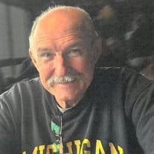
May the Lord receive John into His loving arms this Christmas season and may He Bless the Sidor family at this difficult time.

https://www.vermeulenfh.com/m/obituaries/John-Sidor/Memories

Sharing this link for your information. Visitation is Monday, 2:00-8:00pm at Vermeulen Funeral Home in Plymouth, with Rosary at 7:00pm.
Funeral services are Tuesday, in state at 10:00am at Our Lady of Good Counsel Church in Plymouth, with mass at 10:30am. Burial at St. Hedwig Cemetery in Dearborn Hts., MI.
May our friend and colleague, John Sidor, rest in God's eternal peace!

