Polish American Congress
Michigan Division
11333 Jos Campau, Hamtramck mi 48212
Tel.# 313-365-9400

Annual Radiothon
Saturday, November 25, 2023

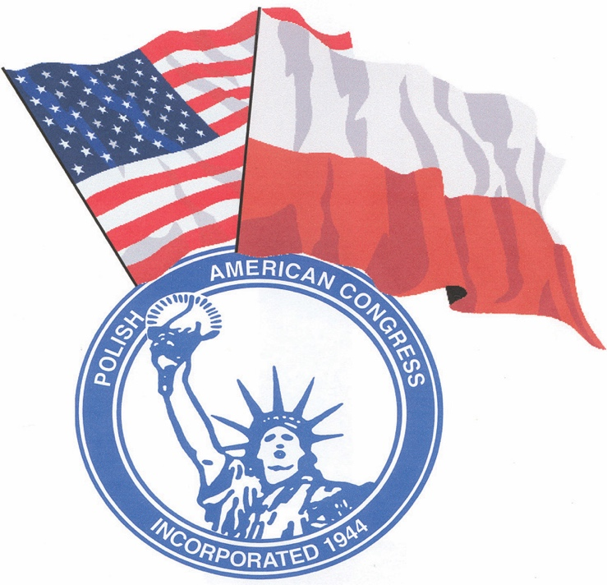
Nothing about us- without us!

Please support us with a financial donation
by calling 313-365-9400 or
mailing your donation to the office, address above.

Please write check to PAC MI
Any donation greatly appreciated. Thank You!

