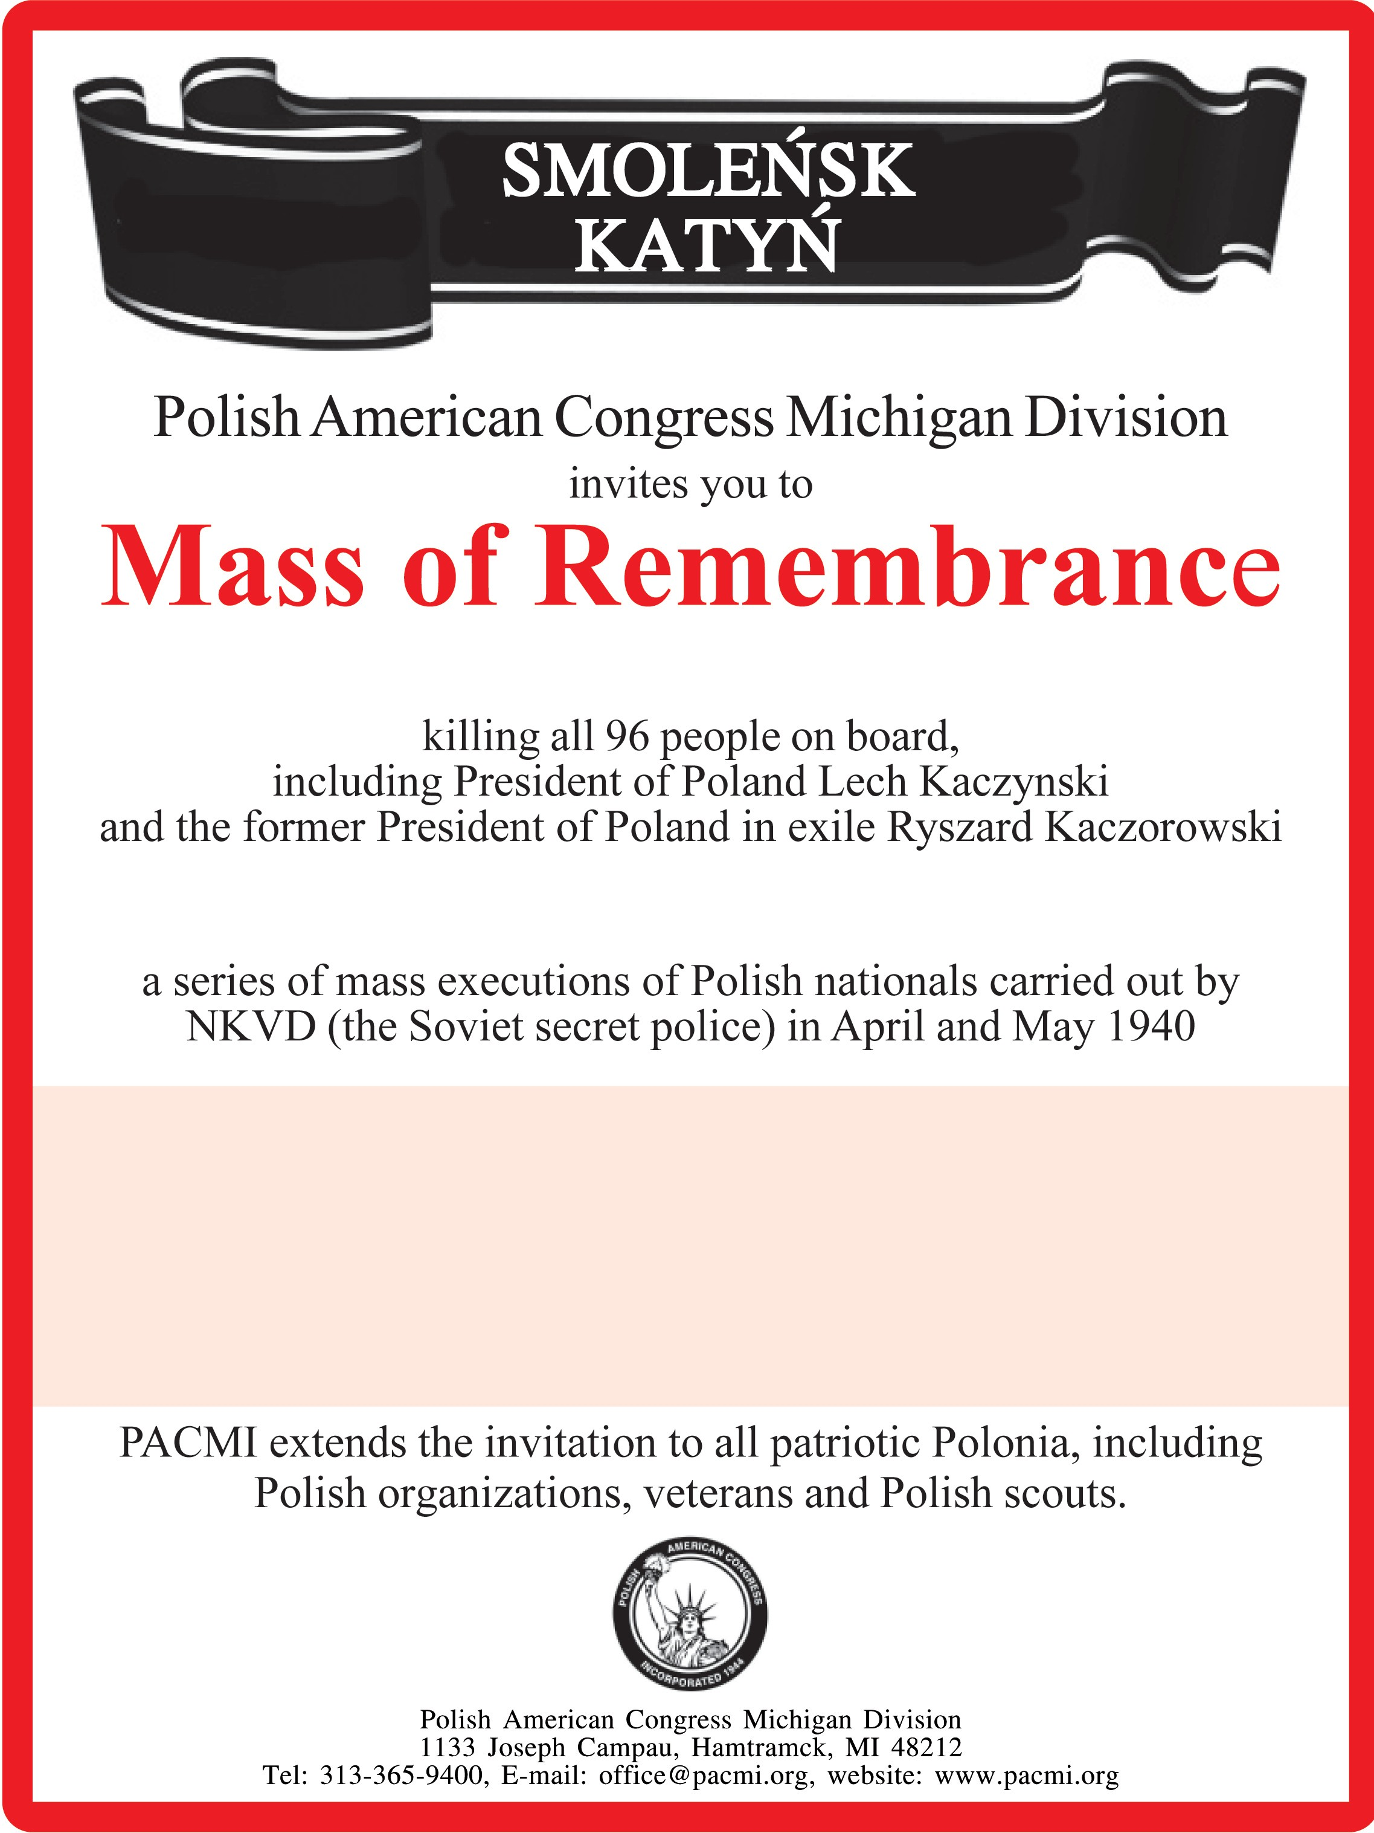

13th Anniversary of Smolensk Polish Air Force crash

83rd Anniversary of the Katyń Massacre St. Faustina Church
14025 E. 12 Mile Rd. Warren, MI
Sunday, April 23, 2023
5:00 pm

