Dear Friends of Ukraine,

The world watched in dismay President Biden’s remarks about “a minor incursion” during a press conference on Wednesday afternoon. In a response to a question posed by a correspondent about the Kremlin’s continued aggression against Ukraine, President Biden stated: “It’s one thing if it’s a minor incursion, and then we end up having a fight about what to do and not to do.”

Such remarks are not conducive to reinforcing a strong, united effort to assist Ukraine, or enhancing a dynamic strategic partnership between the United States and Ukraine. The Ukrainian National Information Service (UNIS) urges you to contact the White House immediately to express your deep displeasure and discontent with the President’s remarks.

Below please find “Quick Guide” infographics and a sample text in your outreach to the White House. Your immediate action is requested!

Also, please find attached the Ukrainian Congress Committee of America’s (UCCA) statement regarding the President’s remarks.

To contact the White House, please call: (202) 456-1111 or visit the website at: whitehouse.gov/contact

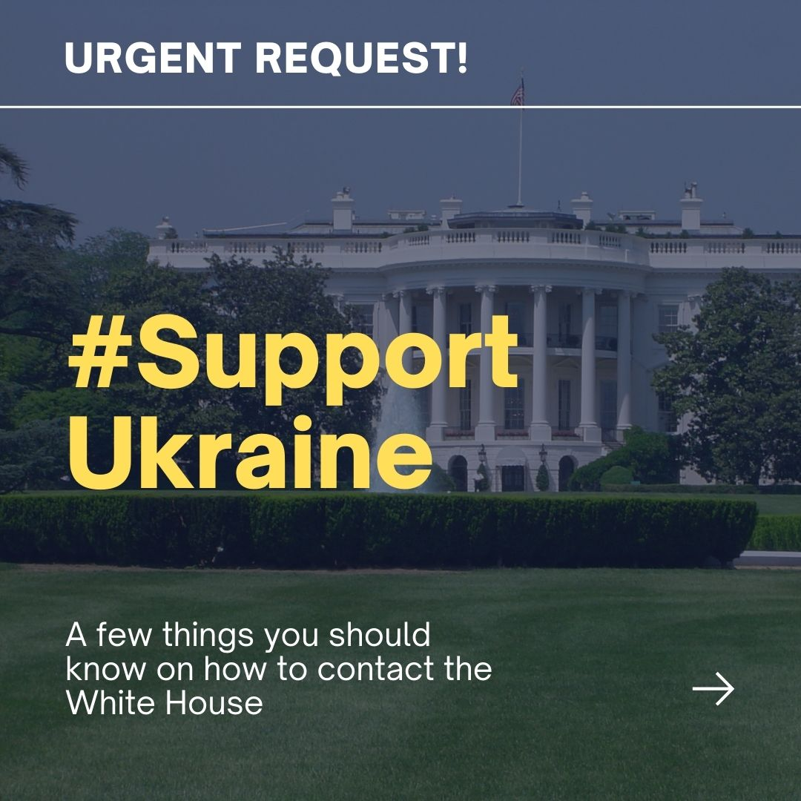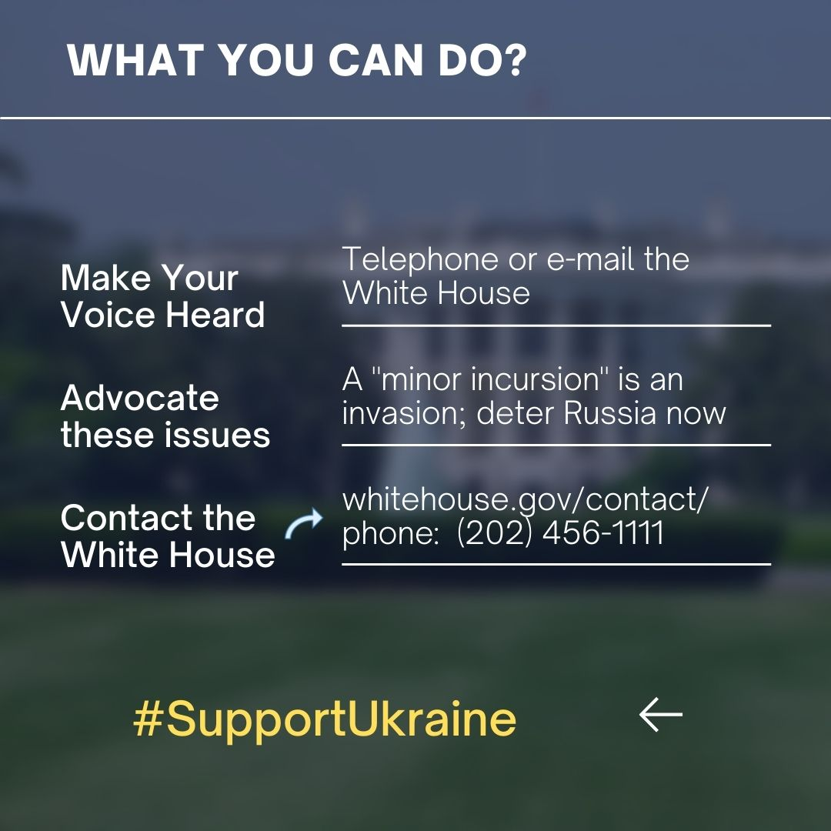

SAMPLE TEXT:

Dear President Biden:

I am deeply incensed by your remarks during Wednesday’s press conference. Qualifying Russia’s actions in Ukraine on a sliding scale of response by the United States and the West is irresponsible at best, dangerous at worst. Such comments could prove to strengthen the Kremlin’s resolve for continued aggressive exploits against Ukraine, including further invasion into sovereign Ukrainian territory. ANY incursion by Russia against Ukraine must be met with severe and punishing consequences.

As a strategic partner of the United States, Ukraine deserves our full support for deterring Russian aggression, which includes imposing immediate punitive sanctions, providing a surge of military assistance, and expediting Ukraine’s accession to NATO.

The United States provided commitments to Ukraine in 1994 with the signing of the Budapest Memorandum. Please uphold those obligations by suppressing the Kremlin’s aggressive actions against Ukraine.

Sincerely,

Please circulate this infographic widely to your family and friends and post onto your social media channels – Facebook, Instagram, TikTok, and Twitter.

Should you have any questions or comments, please contact the Ukrainian National Information Service (UNIS) at: unis.sawkiw@gmail.com.

~~~~~~~~~~~~~~~~~~~~~~~~~~~~~~~~~~~~~~~~~~~~~~~~~~

Ukrainian National Information Service
311 Massachusetts Avenue, NE
Washington, DC 20002
tel: (202) 547-0018
fax: (202) 547-0019
e-mail: unis.sawkiw@gmail.com
Twitter/Instagram: @UNISdirect
Facebook: https://www.facebook.com/pages/Ukrainian-National-Information-Service-UNIS/198575390157933

Visit us on the web at: www.ucca.org

--

